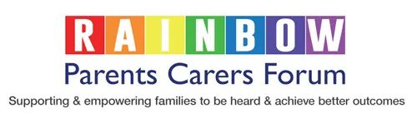
Sleep Workshop

Cerebra will be hosting a free workshop on ‘Understanding and Supporting your Children’s Sleep’.

Your name: ……………………………….
Please state preferred dates for this session, which fall on a Tuesday, Wednesday or Thursday in September:
…………………………………………………………………………
Time: 10am – 2pm
Location: TBC
- The main focus of the workshop will be on how to build on your knowledge and understanding of sleep and what impacts/improves it
- To increase your skills when addressing issues of settling, night waking, early rising and sleeping alone
- To improve your confidence to apply information gained to your own situation.

If you are interested in attending this event, then please complete and return this form to:
admin@rainbowpcf.org.uk

Cerebra is the charity dedicated to helping families with children with brain conditions discover a better life together.

